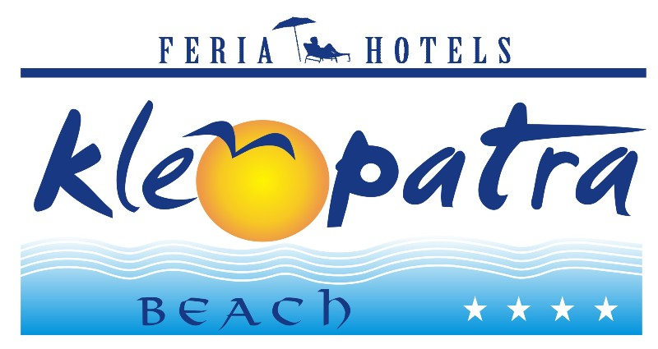
KLEOPATRA BEACH HOTEL
2023 SUMMER ALL INCLUSIVE CONCEPT

Breakfast 08:00 - 10:00
Snack at pool 10:00 - 12:30 & 14:00 – 17:00
Lunch 12:30 – 14:00
Coffee and cake 17:00 – 18:00
Dinner 19:00 – 21:00
Lobby bar, local drinks 10:00 - 23:00

* The time can be changed in the season
* It‘s not allowed to serve alcohol drinks under 18 years old guests.

Free of Charge Services (included on All Inc.)
TV (Sat)
Turkish Bath (Entrance)
Table Tennis
Dart
Beach Volleyball
Fitness Room
Pool sun bed and umbrella

Service with an Extra Charge
All import drinks (including Miller and Beck’s beer)
Mini bar-Room Services
Telephone and Fax
Safe box in the room
Sauna
Massage
Peeling
Watersport
Doctor
All kind of ice-cream, waffles, all cakes outside the buffet
All fresh juices
Internet corner
Sun bed and umbrella on the beach
A la carte lunch & dinner which are served at the snack bar or beach
Turkish coffee
Wi-Fi

